**Assignment No**: 07

**Aim**: The figure shows a single hidden layer neural network. The weights are initialized to 1‟s as shown in the diagram and all biases are initialized to 0‟s. Assume all the neurons have linear activation functions. The neural network is to be trained with stochastic (online) gradient descent. The first training example is [x1=1, x2=0] and the desired output is 1. Design the back-propagation algorithm to find the updated value for W11 after back propagation. Choose the value that is the closest to the options given below: [learning rate =0.1]

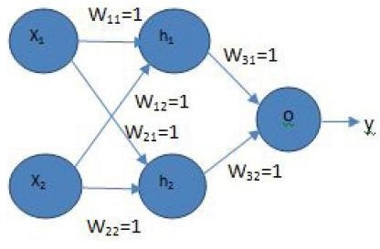

# Objectives:

1. To design a back-propagation algorithm.

# Software Requirements:

Ubuntu 18.04

# Hardware Requirements:

Pentium IV system with latest configuration

# Theory:

Back propagation, short for "backward propagation of errors," is an algorithm for supervised learning of artificial neural networks using gradient descent. Given an artificial neural network and an error function, the method calculates the gradient of the error function with respect to the neural network's weights. It is a generalization of the delta rule for perceptrons to multilayer feed forward neural networks.

The "backwards" part of the name stems from the fact that calculation of the gradient proceeds backwards through the network, with the gradient of the final layer of weights being calculated first and the gradient of the first layer of weights being calculated last. Partial computations of the gradient from one layer are reused in the computation of the gradient for the previous layer. This backwards flow of the error information allows for efficient computation of the gradient at each layer versus the naive approach of calculating the gradient of each layer separately.

Back propagation's popularity has experienced a recent resurgence given the widespread

adoption of deep neural networks for image recognition and speech recognition. It is considered an efficient algorithm, and modern implementations take advantage of specialized GPUs to further improve performance.

# Formal Defination

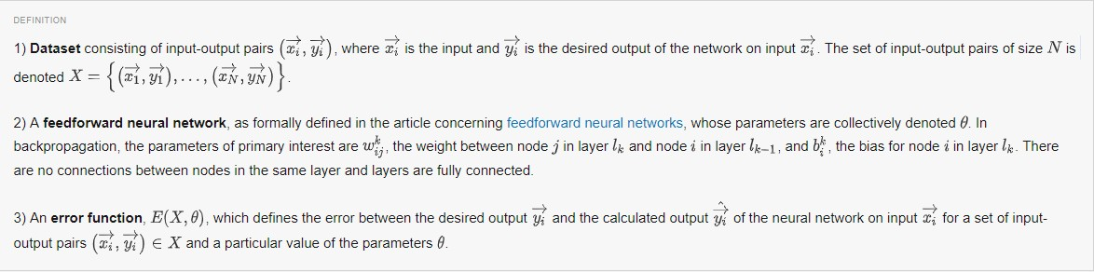

**The Backpropagation Algorithm**

Using the terms defined in the section titled Formal Definition and the equations derived in the section titled Deriving the Gradients, the backpropagation algorithm is dependent on the following five equations:

For the partial derivatives,

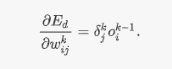

For the final layer's error term,



For the hidden layers' error terms,

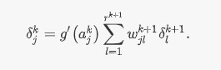

For combining the partial derivatives for each input-output pair,

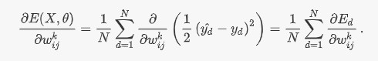

For updating the weights,

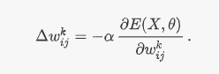

# The General Algorithm

**Conclusion:**

Thus we have designed back propagation algorithm.